**Symbiosis School, Nasik.**

**Std: X Term I (2020-21)**

**Subject: English Language & Literature - Worksheet – 36**

**Lesson : Chapter 9 – Madam Rides the Bus By Vallikannan**

**About the Author**

Vallikannan is the pseudonym of R. S. Krishnasamy (12 November 1920 - 9 November 2006), a Tamil, writer, journalist, critic, and translator from Tamil Nadu, India. He wrote a total of 75 books in his life - novels, novellas, poetry collections, plays and essay anthologies. In 1978, he was awarded the Sahitya Akademi Award for Tamil for his critical work on modern Tamil poetry Pudukavithaiyin Thottramum Valarchiyum (lit. The birth and growth of Modern Tamil Poetry).

**Madam Rides the Bus - Introduction**

The lesson “Madam Rides the Bus” is about a brave eight year old who had a strong desire and along with it, the courage to fulfill it. She liked gazing at the hustle and bustle of the street and her favourite part was the sight of a bus arriving and departing. Thus, she developed a deep desire to travel by bus. For that, she needed all sorts of information about the bus journey, collect the bus fare and then plan it so that she could be back at home before her mother woke up from her afternoon nap. Thus, the story brings us recounts of how innocently but responsibly she fulfilled her deepest desire and her experiences on the bus ride. How an incident makes her realize the reality of death.

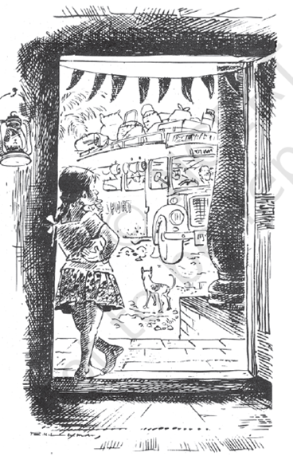 

**Madam Rides the Bus - Summary**

The lesson is about an eight year old girl named Valli, who did not have friends to play with and so she would spend her time by looking at the outside affairs going on the street. Her favourite part was to look at the bus that passed by her village every hour. It gave her endless joy to look at the new set of passengers each time the bus crossed by. Gradually, even she wished to travel by bus. Soon, the wish turned into a desire and therefore, she made it her mission to fulfill it. She started listening to the conversations between her neighbours who frequently travelled by bus and in the process, would ask a few careful questions here and there to collect more information. Just like this, she knew that the town is six miles away from her village and it took the bus forty five minutes to travel one side. One-sided fare was thirty paise making it sixty for a back and forth ride. Therefore, she started planning and re-planning so that she could sneak out during her mother’s afternoon nap and come back without her knowing anything. She needed to save the money which was not easy as she had to resist the temptation of candy, peppermint and merry-go-round. Finally, she saved enough money and one fine day, the brave eight year old took the bus during it’s not very busy hours. She refused to take any help from the conductor or fellow passengers. It was an amusing sight for everyone to see such a small girl all alone acting like an adult. The conductor was of the joking sort and thus, referred to Valli as a grown up ‘madam’. Short-heighted Valli would stand on her seat to be able to see clearly from the window while everyone advised her to sit for her own safety. Each time someone would poke their nose in her business, Valli would get annoyed as she did not consider herself a child. She did not want to be friends with an elderly lady who was worried about her because she thought she was not socially-capable enough. She enjoyed seeing what was going on outside and the sight of a running cow in the middle of a road was abruptly a funny scenario for her. Upon reaching the town,  she refused to get down the bus because she was too afraid to do so alone. While returning, she carried extreme enthusiasm until she saw a cow lying lifeless on the road. It was the same cow that was so joyous previously. Valli got terrified at the fact that how a creature so full of life can instantly turn into something horrible. She sat down silently for rest  of the journey. Upon reaching home, she found her mother and aunt talking about the endless possibilities in the world outside. Valli affirmed to what her mother was sayingleaving both of them astonished. She then justified her reaction by mentioning that she was casually agreeing to what her mother was saying.  Her aunt then referred to Valli as a nose-poking child who acts like a grown up lady but only Valli knew what she was referring to because, after all, no one knew about her bus journey.

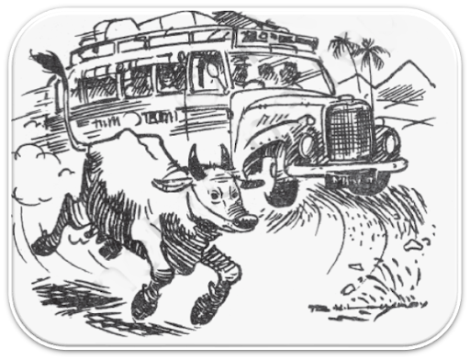  

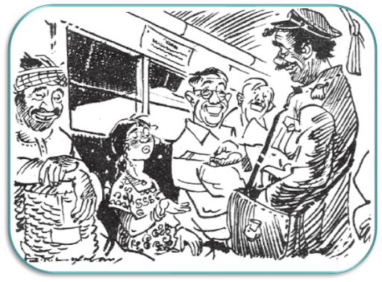  
**Word Meanings**

Curious- eager to know or learn something

Wistfully- longingly  
Kindle- set alight (fire), here, feelings  
A slang expression- informal words, often used within a close group

Discreet questions- careful questions

Devoured- read quickly and eagerly (here)  
Canvas- a coarse fabric  
Blind- a partition

Haughtily- proudly

Repulsive- causing strong dislike

Curtly- rudely brief or abrupt  
Drivel- silly nonsense

Thriftily- spend money carefully  
Resolutely stifled- suppressed/ controlled with determination

Ventured out- went cautiously, courageously

Hamlet: a small settlement with a few houses.  
Gobbling up: to swallow or eat hastily

Glee- happiness and joy

Thoroughfare- a busy public road  
Merchandise- things  for sale  
Railroad crossing- an intersection where a railway line crosses a road or path

Spreadeagled- spread out

Haunted- returned repeatedly to her mind; was impossible to forget

Pokes her nose- takes an interest in something that doesn’t concern her

**Write a character sketch of Valli.**

**Ans:** Valli was an eight-year-old girl born in a small village. However, she was a very curious girl. She spent her time standing in the front doorway of her house, watching what was happening in the street outside. Watching the street gave her many new and unusual experiences. Her curiosity about travelling on the bus to the town urged her to plan a bus trip. She was very meticulous in planning for the trip. She calculated the distance between her home and the town, and the time it took for a trip up and down by bus. She was a determined girl. She saved money by resisting temptations to buy her favourite things like peppermint, balloons, toys, etc. and suppressing her keen desire to ride merry-go-round at the village fair. Valli also proved to be very impressive and bold by finally deciding to ride in the bus. Her childish innocence veiled by her smart and bold outlook which amused the conductor who offered her a seat in the bus. Valli thoroughly enjoyed her ride to the town, and laughed and clapped when the young cow ran on the middle of the road in front of the bus. But her enjoyable bus ride became a nightmare on her return journey. She saw the same cow lying dead on the road. This sight haunted her, dampened her spirits, and saddened her. This is typical of the tendency of a matured person. She refused to look out of the window thereafter. Valli, on the whole, can be described as a curious, joyful, disciplined, smart, bold, and at the same time, a mature girl.

**Write a character sketch of The Conductor.**

The **conductor** was a fun loving and jovial person. He was helping and kind to Valli but also poked fun at her over confident attitude. The **conductor** mimicked Valli's tone and instructed her to feel comfortable. The **conductor** was concerned about the girl and asked her if her mother would be looking for her

The conductor was a polite, cheerful and good natured man. He was full of patience and never lost his temper. He tried to make his passengers comfortable in every way. He helped his passengers in every possible way. With old people he was as considerate as a son and with children as solicitious as a father. He had evidently a peculiarly warm place in his heart for young people and always cracked jokes with them. He took special care for handicapped persons. He often helped the blind in crossing a road. He created an atmosphere of good temper and kindness that a journey with him was a lesson in natural courtesy and good manners. Once he helped the writer by giving the bus ticket when he was without money. Once he trampled the writer's toe and apologised to him. The writer was impressed with his good nature and full of praise for him.

**Concept Based Questions**

Q1. Why did Valli kept standing in front of the door?

Q2. Why did the conductor want Valli to sit?

Q3. How was the interior and exterior of the bus?

Q4. How was the view outside the bus when it went through the canal?  
Q5. How did Valli feel on seeing the dead cow on the road?     